Due: September 4, 2015

Historical Research Task
· Compare/Contrast 2-3 artworks within a single artistic movement. Pick a historical art movement to review based on what you are currently interested in visually, conceptually or technically.

Step-by-Step Instructions:
-Select Artistic Movement. Ensure that there is enough information on this artistic movement to fill 4 Process Portfolio pages worth of content.
-Artistic Movement should be pre-1940 for Historical Category.
-Complete Art Analyzing Instructions for both pieces of artwork you select (or three). Use this art analysis to help you figure out how you want to present this information.
-Decide how your compare/contrast is going to be visually appealing. Look at other Process Portfolio examples on the internet. Is it a large fold out Venn Diagram? Are you pitting two pieces against each other on opposing pages? How will you organize information? I cannot tell you WHAT this looks like, you need to be creative.
-Use your art analysis information as the foundation of the comparison. Think about cultural implications.
-You MUST use art vocabulary (elements, principles, aesthetic theories, special language based off of the media or artistic movement) use the vocab sheet Mrs. Rudd has given you, or ask her for help creating a word bank.
-You MUST have some personal investment in this compare/contrast. Why does this information matter to you? What are YOUR ideas about these pieces? WHY did you select them to compare to each other?
-You should have more than a photocopy of each work on the page—you should be supporting your ideas with OTHER images by these artists, or other artists that inspired their work (and then justify the reason why these other visuals are included).
-All sources need to be cited.
-This should be a very hefty, full, four Process Portfolio pages.
-The CONTEXT of your IWB page should fit the subject matter.
-Ask as many questions as you need. Use the art reference books on the bookcase to help if possible.
Analyzing Artwork before Reacting--A Step-by-Step Guide
Follow these steps; answer all the questions and you can’t go wrong!
1. Description (It answers the question, "What do you see?")
Pure description of the object without value judgments (Elements of Art) List what you can see in this artwork. Objects, figures, colors, shapes, objects, background, etc. Imagine you are describing it to a blind person. Do this in as much detail as possible and use art terms.
2. Analyze (It answers the question, "How did the artist do it?")

Determining what the features suggest and deciding why the artist used such features to convey specific ideas. Composition (organization of shapes)
- What types of shapes are used in this artwork (i.e. rounded, curved, straight-edged or geometric shapes)?
- Is there a mixture of different types of shapes or are all the shapes similar?
- Are some parts of the composition full of shapes and some parts empty, or are the shapes spread evenly across the artwork?
- Are some shapes repeated or echoed in other parts of the artwork?
- Does the whole composition look full of energy and movement, or does it look still and peaceful? How did the artist create this movement/stillness?
- What is the center of interest in the composition?
- How does the artist draw your attention to it?
Use the elements/principles to reflect upon the art form
- Determination of subject matter through naming iconographic elements, e.g., historical event, allegory, mythology, etc.
- Selection of most distinctive features or characteristics whether line, shape, color, texture, etc.
- Analysis of the principles of design or composition, e.g., stable,
- repetitious, rhythmic, unified, symmetrical, harmonious, geometric, varied, chaotic, horizontal or vertically oriented, etc.
- Discussion of how elements or structural system contribute to appearance of image or function
- Analysis of use of light and role of color, e.g., contrasty, shadowy, illogical, warm, cool, symbolic, etc.
- Treatment of space and landscape, both real and illusionary (including use of perspective), e.g., compact, deep, shallow, naturalistic, random
- Portrayal of movement and how it is achieved
- Effect of particular medium(s) used
- Your perceptions of balance, proportion and scale (relationships of each part of the composition to the whole and to each other part) and your emotional
- Reaction to object or monument
3: Interpretation (It answers the question, "What is the artist trying to say? What is going on in the picture")
- What do you think the artist is trying to say in this artwork? What does it mean?
- What context was the artwork created in? What context are you viewing the artwork in?
- Who is the audience for this artwork? Was this artwork created in reaction to something?
- What is the main theme or idea behind this piece?
- If you were inside this artwork, what would you be feeling/ thinking?
- Does the artwork have a narrative (tell a story)? Is it a religious artwork?
- Is it abstract? Is it realistic? Why?
- How would you explain this artwork to someone else?
- Evidence: What evidence inside or outside the artwork supports your interpretation?

4: Evaluation (What do I think about this artwork? How do I feel about whether the artist was successful in conveying an idea? )

Based upon what you have observed already, give your opinion of the artwork. You MUST give reason.
- Use aesthetic theories to help evaluate
- Is it a good artwork?
- Criteria: What criteria do I think are most appropriate for judging the artwork?
- Evidence: What evidence inside or outside the artwork relates to each criterion?
- Judgment: Based on the criteria and evidence, what is my judgment about the quality of the artwork?
- “Franz Marc has created an effective expressive painting, because the hot colors and lively brush marks he has used add to the overall feeling of energy and excitement his is trying to create.”
- “The overall mood of this drawing would be improved if Kathe Kollowitz had used strong, dramatic shadows, instead of pale tones. Dark tones would develop the feeling of fear and loneliness in this image.”
Example:
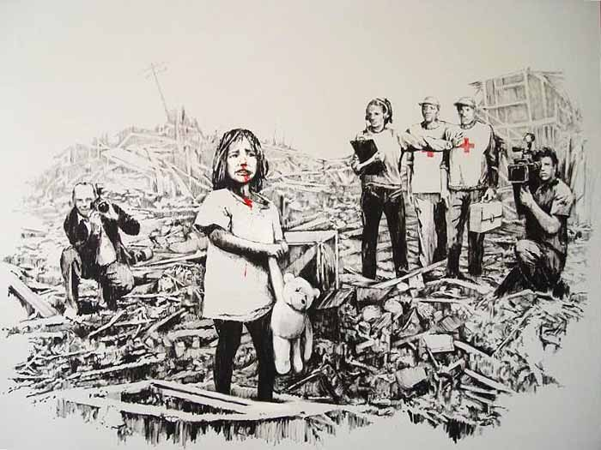

This artwork contains a sad little girl that is bleeding from the nose and holding a teddy bear, all while she is standing in a landscape of rubble. There are five people in the background that are looking directly at the little girl; two men are photographing her, a woman with a clip board and headphones has her arm extended that prevents two men wearing red crosses from interfering with the sad event that is occurring.
The artist used jagged lines to create the disorder and destruction surrounding the little girl. The little girl is placed slightly off-center in the foreground for the viewer in order to place greater emphasis on her, while placing the observers in the background. The most noticeable use of the elements of art is the use of only one color, red. He used an intense red to draw the viewer’s attention to the blood on the girl’s face and on the Red Cross men that want to help the child. The placement of the people in the artwork and the use of red place great emphasis on the child being depicted because it makes the viewer’s eyes refer back to the little girl.
The destruction surrounding the child, blood on her face, and her facial expression tells us that it is a sad and uncomfortable environment. The scene is also disturbing because the adults are not helping the innocent and crying child. Instead, they are taking advantage of her situation and documenting it for their own benefit. The artist utilizes this scene to make his audience aware of the great lengths that the news media is willing to go to in order to obtain a “touching” story.
This artwork is very powerful and thought provoking because the artist provides a different perspective for his audience about the news media. He confronts the viewer with a dramatic scene of helplessness in order to get his social message across. Therefore, this artwork possesses and meets the criteria for the aesthetic theory of instrumentalism.

