IB Art Year 1
Conceptual Self-Portrait Assignment
& Self Evaluation Criteria

Name _______________________Date __________________________

Self Evaluation Due: 9/4/2015
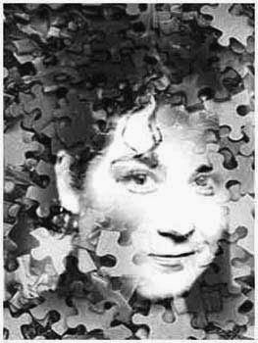
Definitions:
conceptual art
: an art form in which the artist's intent is to convey a concept rather than to create an art object
self-por·trait : a portrait of oneself done by oneself
Resources To Start Your RESEARCH (IWB worthy):
- http://www.artlex.com/ArtLex/s/self-portrait.html
- http://www.channel4.com/culture/microsites/S/selfportraituk/techniques_09b.html
- http://www.mishabittleston.com/conceptual/self_portrait/
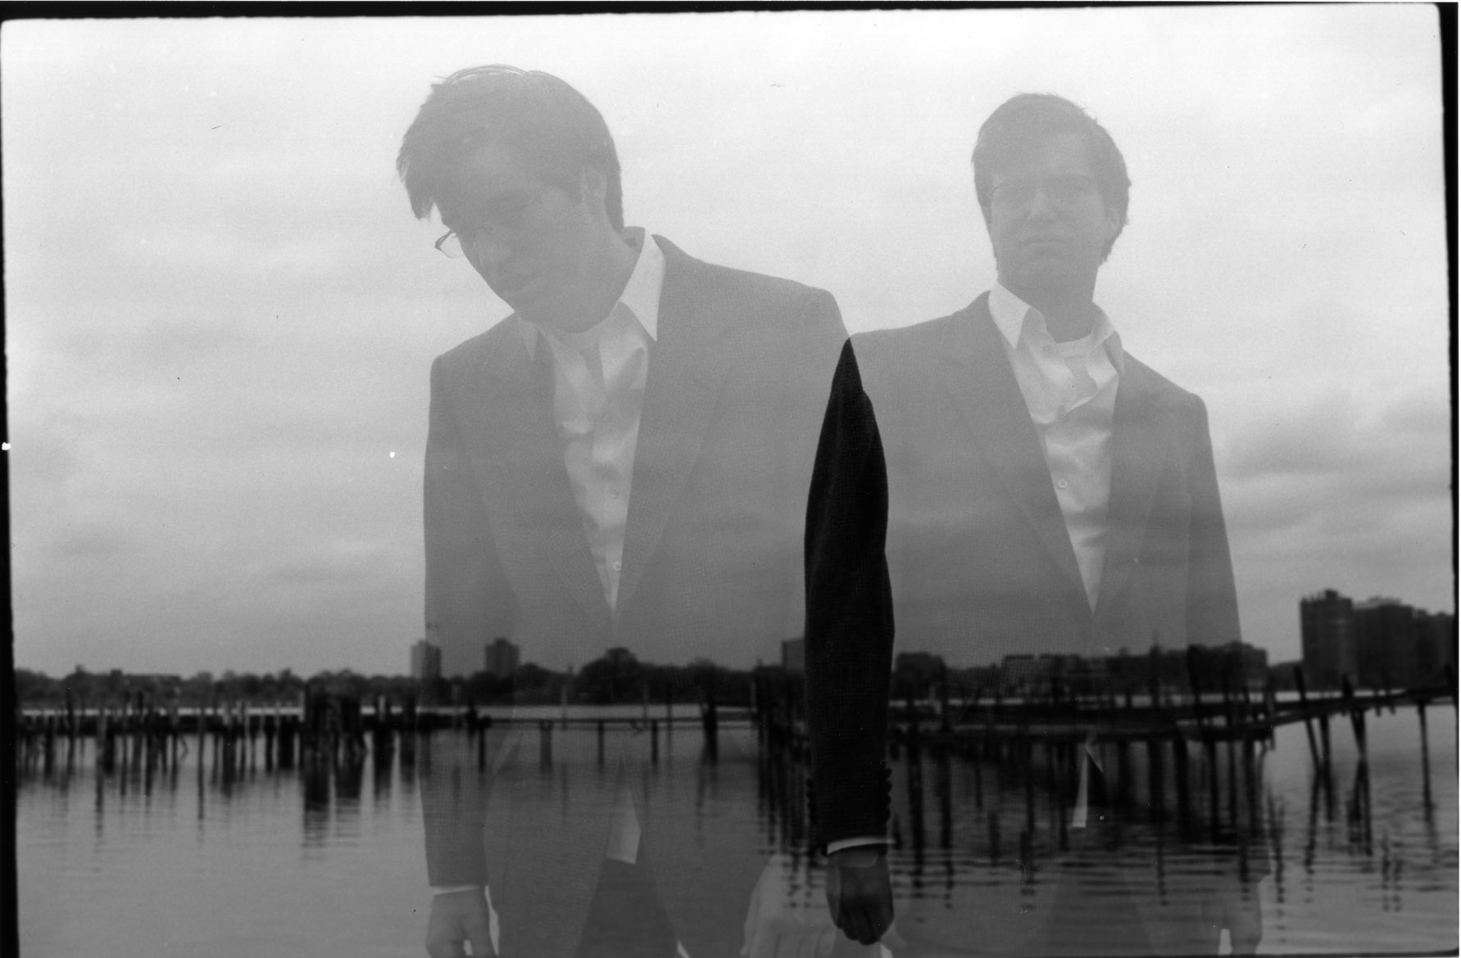
Assignment Criteria: For this assignment, you need to create a ‘conceptual self portrait.’ The finished work does not need to be realistic and may be 2-D or 3 – D. You are responsible for collecting the material you want to work with in creating this portrait. Non-traditional approaches to solving the CSP problem are encouraged.

IWB Pages Necessary:
-Brainstorm Page, Thumbnails, Practice/Trial and Error Page, Process Page (How your artwork came together?, Reflection on outcomes Page.

SELF EVALUATION:
I chose the following material to create my conceptual self portrait:______________________.
I chose this material because:

I think the CSP project shows my artistic style to be:
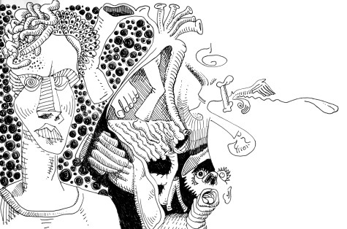
Delicate - bold - detailed - sketchy - realistic - abstract - precise - expressive or __________
I think my CSP looks especially good because:

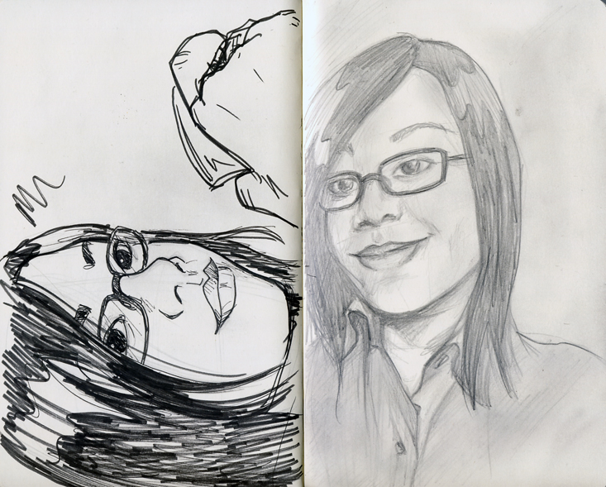
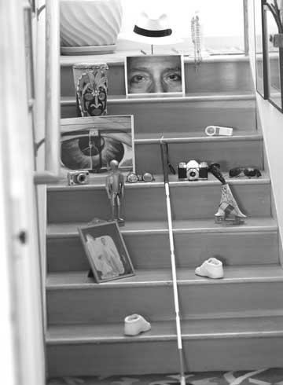
The part of my CSP I would most like to improve would be: (describe what you’d do differently if you had to do this project again in the space below):

I spent ________# hours researching, planning and creating this project outside of class time.
The areas/disciplines I researched included:

I developed these ideas before pursuing my final composition idea:

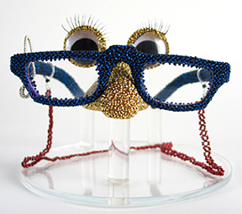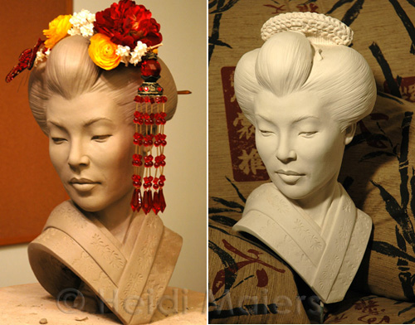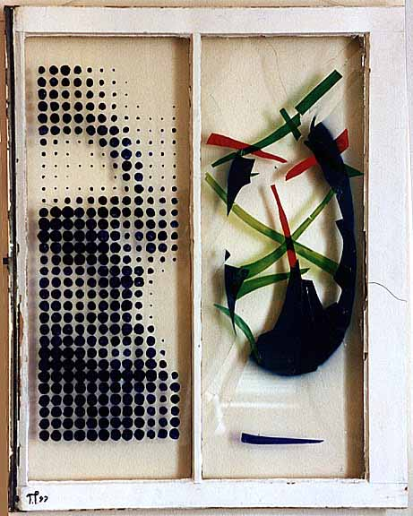
Ms. Rudd’s CSP Project Evaluation Rubric
7 = SUPERIOR Coherent communication, effective application of media and technique, original and insightful, comprehensive in research and concept, highest competency of technique
6 = EXCELLENT Coherent communication, mostly effective application of media and technique, mostly original and insightful, comprehensive in research and concept, competency present
5 = HIGHLY PROFICIENT Insightful, Perceptive, Comprehensive, Mature, Original
4 = PROFICIENT Clear, Adept, Capable, Mostly Original
3 = SATISFACTORY Adequate, Straight Forward, Conventional
2 = LIMITED Incomplete, Lacks Development, Vague, Superficial
1 = POOR Minimal process, Disjointed idea, Poor construction, Boring

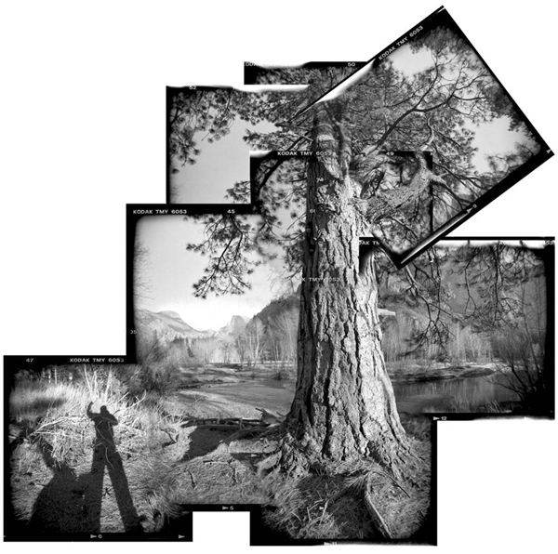
Additional comments:

